TRAINING DOCUMENT

- Initial call involving basic interaction about our clients and workplace.
- Giving a brief overview about different aspects of work involved in home care companies.
- Website Training involves the following activities:

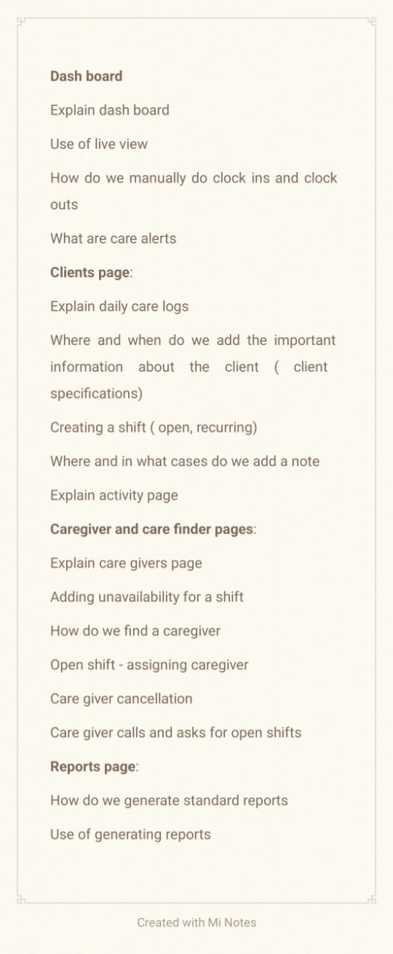

- Testing different case scenarios on daily basis with live examples.

