SCHEDULER TRAINING DOCUMENT
Below is the summary of the topics covered in the training
Initial Training Duration – 2-3 weeks
Practical Training Duration – 2 weeks

- Initial call involving basic interaction about our clients (In-Home Care Agencies) and workplace.
- This includes explaining about the working hours (Regular scheduling shift and on call shift)
- How to work in a team, team collaboration
- Work ethics to be followed
- Giving a brief overview about different aspects of work involved in home care companies.
- How to communicate with clients and caregivers
- Admin related work.

- In depth training on the Well sky

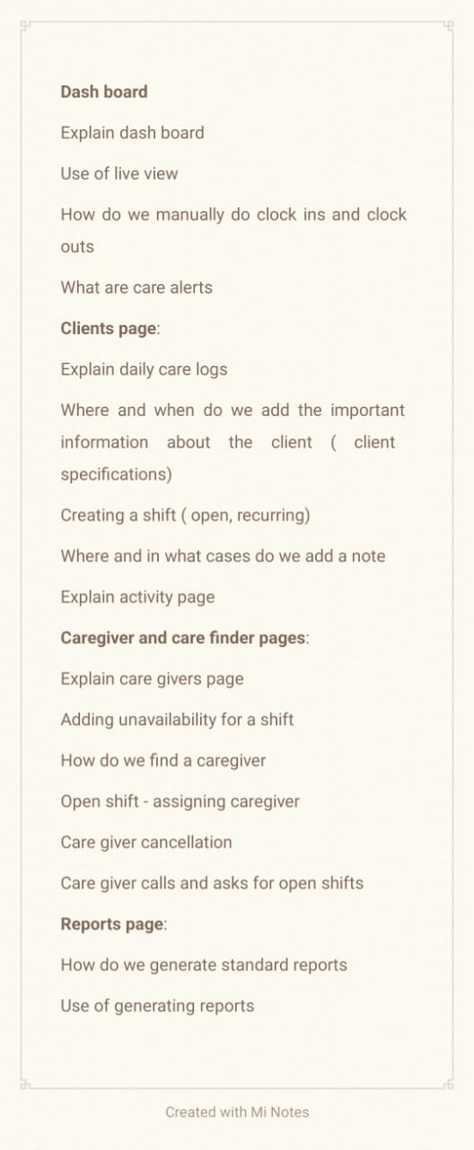

- Training on different case scenarios on daily basis with live examples.

- This includes client scenarios and caregiver scenarios
- How to interact with clients regarding their schedules and addressing any concerns they have.
- How to interact with caregivers with the questions they ask and with concerns they have
- How to handle extreme situations between a client and their care givers.
- What kind of responses or answers should be given to the questions the client/caregiver asks.

- Below are topics/Case scenarios completely covered under training
- Types of Scheduling:
How do we plan a schedule for a New Client?
How do we plan a 24-hour care?
How do we plan Hospice care?
How do we plan Couples Care?
How do we plan a recurring shift Calendar for a client?
How do we add new Care/Shift for already Existing Clients?
How do we plan Emergency Cancellations?
How do we change the shift timings upon request from client or Caregiver?
How will you plan, if client tested Covid + and If Caregiver tested Covid +?
Planning a schedule for returning Client?

  - Caregiver Cancellation:
A. Less than 6 hours
B. More than 6 hours
C. If Caregiver is sick before coming to shift
D. Covid +
E. Sick during shift
F. Caregiver Car problem.
  - Client Cancellation:
A. Sick before shift
B. Client visiting or going out for dinner
C. Client cancellation admitted in hospital
D. If the client is tested covid +
E. If the client is upset with the Caregiver or not happy with the care.

- Types of Calls from Caregivers:
Caregiver asking permission to leave early
Caregiver calling for Clock in and Clock Out
Caregiver calling and informing that she is running late to her shift
Caregiver calling for Re-Scheduling
Caregiver calling for available Shifts
Caregiver calling and informing that she is not feeling well during her shift
Caregiver reporting issues/concern on client and another caregiver.
Caregiver calling and informing that she doesn’t want to work with the client nor happy to work during the shift and after the shift.
Caregiver calling and requesting a leave or off
Caregiver calling and asking for directions to the client’s place.

- Types of Calls from Clients:
Client calling us and informing about change in care plan
Client calling for re-scheduling
Client calling for cancellation
Client calling for Caregiver off the Shift (Client doesn’t like Caregiver)
Client having concerns about the Caregiver
Client calling and informing to add some rules for the Caregiver’s during the shift.
Client calling for their shift calendar
Client calling for information about their shift
Client’s family calling up and informing the client has passed away.
Client calling for adding new shift
Client calling to inform to stop their care from the agency
Clients calling and refer their family and friends for care
New client calling and asking information about Home Care Services
Clients calling for their Billing amount
Clients calling and informing about the change in address
Clients calling and informing they have doctor’s appointment and requesting caregiver to take them there.

